
www.greentechenergy.com

CASE STUDY

Cintas
Landover, Maryland

Cintas Corporation provides services to businesses of all types throughout North America. More than five million people go to work every day in Cintas uniforms, which the company rents, launders, repairs and replaces. Cintas operates more than 390 facilities in the U.S. and Canada, including four manufacturing plants and eight distribution centers. In its plant in Landover, MD, Cintas contracted with GreenTech Energy Services to design and implement an energy savings system.
In some areas of the plant, existing 400-watt metal halide fixtures were replaced with T8’s, bringing the wattage down from 465 watts per fixture to 152 watts per fixture. In other areas of the plant, existing 8-foot T12 high-output fixtures were retrofit with four-lamp T8’s, lowering the wattage from 257 to 87. Sensors were installed in the first and second level stock areas, as well as in all offices, where T12’s were also retrofit with low-wattage T8’s.

Despite sharp reductions in energy use, light levels actually improved in every area. Prior to the project, foot-candles ranged from 10 to 32; readings after the project ranged from 46 to 89. The higher light levels have enhanced the workers’ productivity, comfort and safety. The newer lights also run cooler, which is important in a hot, humid work environment. The project is expected to pay for itself in less than one year.

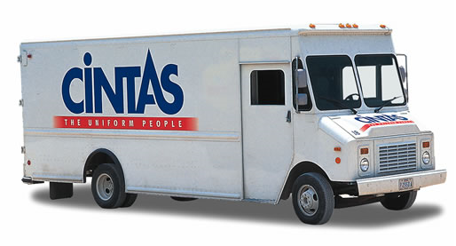
THE SAVINGS
Total Program Costs | $30,571
Total Payback Period | 0.7
Utility Rebate | $4,930
EPACT Tax Savings | $9,345
KW Saved | 23
KWH Saved | 141,364
Energy Cost Savings | $20,949
Operational Cost Savings | $917
Total Savings | $21,866
GreenTech did a great job. Your team was easy to work with and we have so much more lighting.
Mihir Gada, Plant Manager

ENVIRONMENTAL IMPACT
Reduction in Carbon Dioxide (pounds) | 212,046
Reduction in Sulfur Dioxide (grams) | 791,639
Reduction in Nitrogen Oxide (grams) | 353,410

