

CASE STUDY

Staples Warehouse & Distribution Center
Memphis, Tennessee
Staples contracted with GreenTech Energy Services to design and implement the following energy savings solutions in its warehouse and distribution center in Memphis, TN.
- Outdated 400-watt metal halide fixtures were replaced with state-of-the-art T5 lighting. The new fixtures provide instant on and off, which eliminates warm-up time, and have reduced energy consumption by up to 60%.
- T8 fluorescent lights with high-wattage lamps were retrofit with lower wattage lamps (a reduction from 32 watts to 28).
- Some fixtures were relocated to make the layout more uniform.
- Sensor controls were installed where applicable, which further reduced energy consumption by automatically shutting off the lights in unoccupied areas
- On average, energy use was reduced by about 200 watts per fixture, while light levels actually improved. For example, footcandles rose from 11.1 in the loading dock area to 32.9, while in one of the aisles, levels went from 8.5 to 25.

THE SAVINGS
“The GreenTech crew was very professional – they were clean, quiet, and careful to work around our schedule,” says Dan Harris, Facility Maintenance Manager. “The associates are very happy with the results. There’s more lighting in the picking areas and the whole place is brighter.”

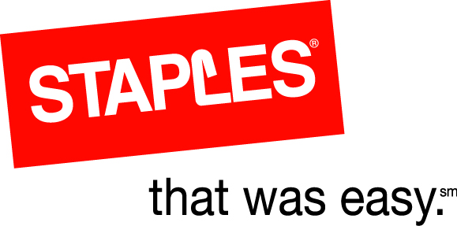

Total Program Costs | $224,123
Total Payback Period | 1.9 years
EPACT SAVINGS | $27,750
KW Saved | 146
KWH Saved | 1,056,044
Energy Savings | $95,044
Operational Savings | $6,724
Total Savings | $101,768

ENVIRONMENTAL IMPACT
Reduction in Carbon Dioxide (pounds) | 1,584,065
Reduction in Sulfur Dioxide (grams) | 5,913,844
Reduction in Nitrogen Oxide (grams) | 2,640,109

GreenTech Energy Services, 122 East Kings Hwy, Ste 503, Maple Shade, NJ 08052
Phone: 800-690-0420 Fax: 856-778-1668 www.greentechenergy.com

