**CASE STUDY – MORRISVILLE SCHOOL DISTRICT, MORRISVILLE, PA**

**Energy & Cost Savings:**

* Program Cost--------------$427,165
* Utility Rebate--------------$48,537
* KW Saved-------------------213
* KWH Saved-----------------596,355
* Energy Cost Savings-------$64,777
* Operational Savings------$12,815
* Total Savings---------------$77,592

# Environmental Impact:

* Reduction in Carbon Dioxide (pounds)--894,533
* Reduction in Sulfur Dioxide (grams)-----3,339,588
* Reduction in Nitrogen Oxide (grams)---1,490,888

GreenTech Energy Services was hired to upgrade the lighting in the Morrisville School District. In classrooms, offices, and other interior rooms, obsolete T12 fluorescent lamps were replaced by new T8s, incandescent lamps were replaced by compact fluorescents, and occupancy sensors were installed to assure lights are turned off when areas are unoccupied. In the high school gym, metal halide high bays were replaced by T5 fluorescents with reflectors and lens cages. LED strips were installed in hallway ceilings and all incandescent exit signs were replaced by LED. Outside, metal halide wall packs were replaced by induction wall packs, and mercury vapor cobra heads on parking lot poles were replaced by induction cobra heads. The project **will save the district over $77,000 a year.**

“The input from Greentech during the survey and design stage was crucial in terms of showing the board what was needed, and it also allowed the facilities manager to adjust the scope in a way that made sense,” says Paul DeAngelo, Morrisville Business Administrator. “Thanks to the survey, we found lights that we didn’t even know we had. We discovered an exterior light that hadn’t been turned on for years that we’d been paying for. We got some of that money back from the utility retroactively and then terminated the light.” During the installation stage, GreenTech did three rooms in a hallway at a time. When teachers came in the morning, they could easily compare the finished and unfinished rooms. “The difference was shocking – like night and day,” says Mr. DeAngelo. He adds that the GreenTech crew worked cleanly and quietly, and everything went according to schedule. The end result, he says, has pleased everyone from faculty and administration to the community at large. “Now when people come into the building at night for meetings they can find their way down the hallways. The custodians can see the floors well enough to mop, and when I come in at 6 am, I don’t have to fish around for my office keys in the dark,” says Mr. DeAngelo. “The LED strips shed just enough light without eating up a lot of energy.”

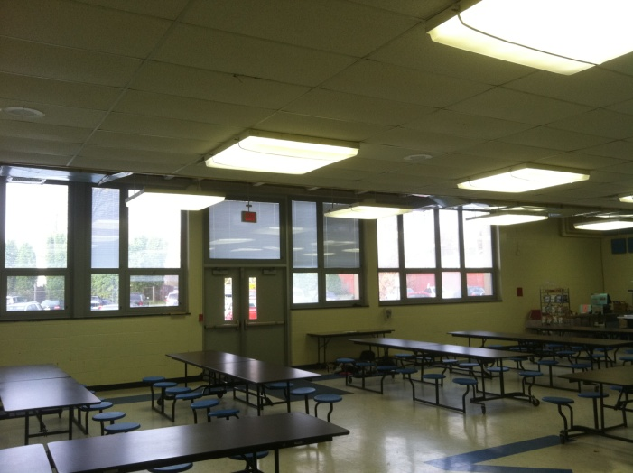 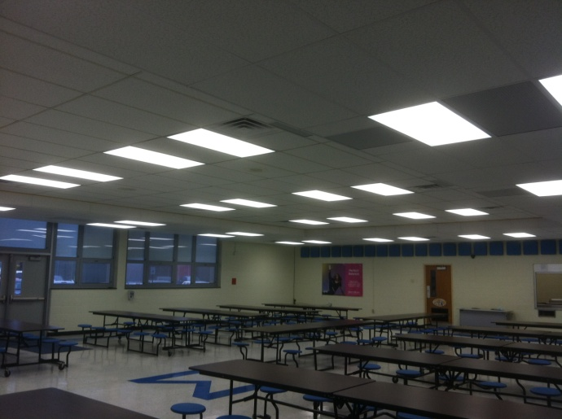

Morrisville School District cafeteria, before and after the lighting retrofit

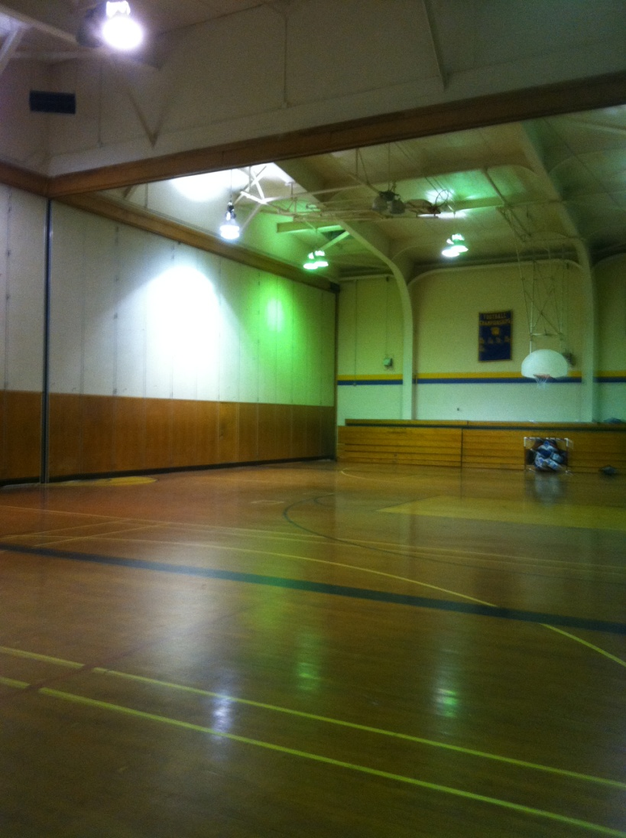 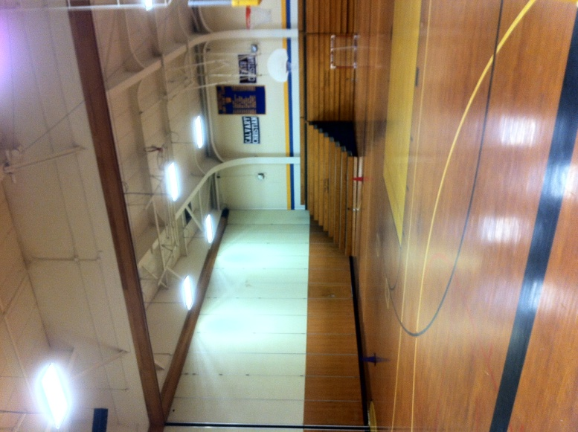

GYM – BEFORE AND AFTER

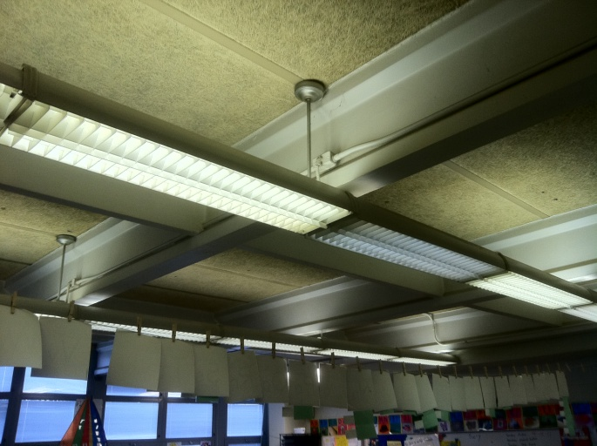 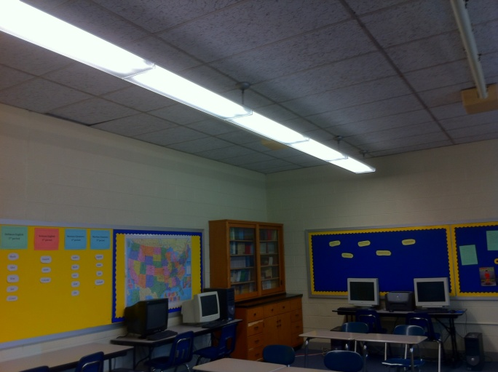

CLASSROOM – BEFORE AND AFTER

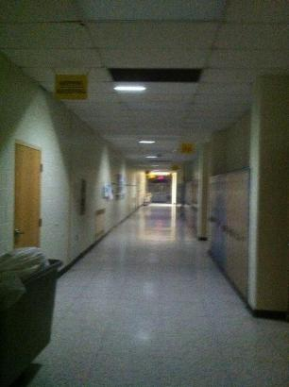

LED STRIPS IN HALLWAYS

GreenTech Energy Services, 122 E. Kings Hwy, Ste. 503, Maple Shade, NJ 08052

P: 856-439-9400 F: 856-778-1668 email: [info@greentechenergy.com](mailto:info@greentechenergy.com) www.greentechenergy.com